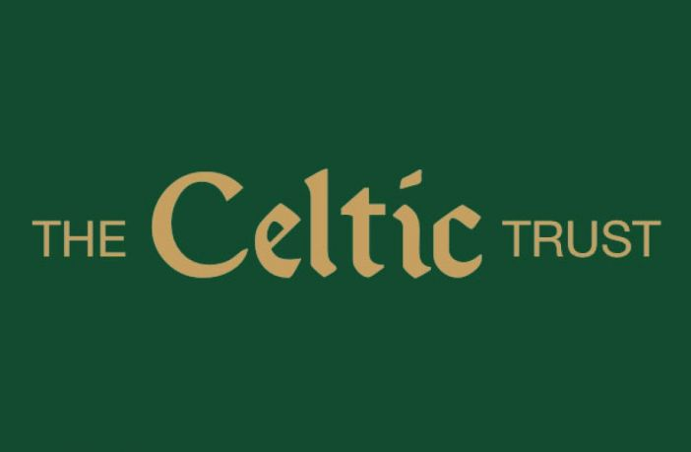
Box 502 103 Byres Road Glasgow G11 5HW
Email Trust@CelticTrust.net

24 February 2021

Mr P T Lawwell
CEO
Celtic Plc

By email to ptlawwell@Celticfc.co.uk

Dear Peter

Celtic Plc (“the club”)
Proposal from The Celtic Trust (“The Trust”)

As shareholders in the club, The Trust herein is making a proposal for consideration by the club’s board of directors. The Trust proposes:-

- Hospitality season ticket holders be offered the option of accepting shares in lieu of cash or other credit in respect of value for seasons 19/20 and 20/21 and
- Season ticket holders be offered the option of accepting shares in lieu of cash or other credit in respect of value for seasons 19/20 and 20/21.

Yours sincerely

David Low
Chair
The Celtic Trust

The Celtic Trust is an Industrial and Provident Society registered with the Registrar of Friendly Societies as The Celtic Supporters’ Society Limited (IP29147R)

